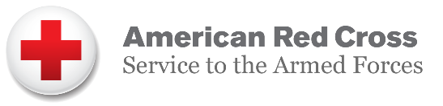

About the Service to the Armed Forces Giving Program

Your SAFGP commitment is extraordinary.

Thank you for your outstanding commitment to the American Red Cross through our Service to the Armed Forces Giving Program (SAFGP). Your generosity makes a difference in the lives of the men and women of the military and veteran communities who have answered our country’s call to military service – especially those who continue to protect our country at home and around the world.

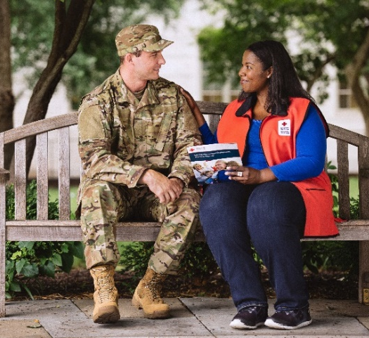
Today, as in decades past, the Red Cross continues to carry out its mission to provide humanitarian support to our military—around the clock, across the country, and around the world under a trusted symbol. With 1.4 million active duty service members, 1.1 million members of the National Guard and Reserve, 22.4 million veterans and 3 million military family members, the Red Cross stands ready to help. Red Cross services include:

- Providing emergency communication services
- Supporting military and veteran medical facilities
- Building strong, resilient families

Thanks to the generous donors that support the Service to the Armed Forces Giving Program, the Red Cross continues to care for our service members, their families and veterans from the day they enlist, throughout their military careers and long after they return home as veterans.

SAFGP members are distinguished leaders dedicated to ensuring that those who have so valiantly served our country will continue to have our support every step of the way. Your donation helps fulfill the Red Cross mission to keep military families connected in times of emergency, support the wounded, ill and injured in medical treatment facilities and help build strong and resilient military and veteran families.

As a valued Service to the Armed Forces supporters, your generosity empowers us to give help and hope to people when they need it most. Our work is important to the nation because it is important to the troops and their families. The Red Cross works on behalf of the American public to ensure that our military personnel get help whenever and wherever they need it.

