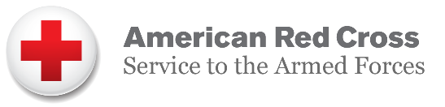
American Red Cross Service to the Armed Forces Mission

Serving those who serve our country.

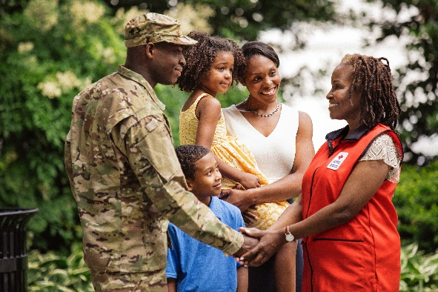
The instant a young man or woman joins the military and raises their right hand to pledge to defend the United States from all enemies, the American Red Cross Service to the Armed Forces brings to bear an array of service that continues with them throughout their career - even after they’ve completed their military duty.

As in decades past, the Red Cross continues to carry out its mission to provide humanitarian support to our military—around the clock, across the country, and around the world under a trusted symbol. With 1.4 million active duty service members, 1.1 million members of the National Guard and Reserve, 22.4 million veterans and 3 million military family members, the Red Cross stands ready to help. Red Cross services include:

- Providing emergency communication services
- Supporting military and veteran medical facilities
- Building strong, resilient families

The Hero Care Network connects military families when emergencies occur, such as the
death or illness of an immediate family member, the Red Cross assists 24 hours a day, 365
days a year through our global communication network. No matter where a service member or
their family is stationed, they can rest assured that the Red Cross will deliver their message in
times of crisis.

Military duty can have physical and psychological impacts on a service member. Every day, dedicated Red Cross volunteers provide support in Veterans Affairs and military medical facilities around the world. These volunteers provide comfort and peace of mind to veteran and military families who are recovering from illness and injury.

The Red Cross helps to build strong military members, veterans and their families. We teach resiliency skills through three impactful programs—Coping with Deployments, Reconnection Workshops and Mind-Body Workshops. We prepare military families to handle emergencies and natural disasters wherever they’re stationed. We even help military families develop job skills, in partnership with the military the Red Cross provides training including Nurse Assistant, Dental Assistant and Water Safety Instructor Training.

America’s military heroes sacrifice their comforts and freedoms to serve our country. The Red Cross works on behalf of the American public to ensure that our military personnel get help whenever and wherever they need it. Our work is important to the nation because it is important to the troops and their families.

